Launch one aws ec2 and install jenkins
1. Launch an EC2 Instance
I launched an EC2 instance using Amazon Linux and created a key pair for secure SSH access. I configured the required security group rules for SSH access.
2. Connect to the EC2 Instance
I connected to the EC2 instance from my Windows machine using Git Bash and the .pem key file. This allowed me to access and manage the Linux server remotely.
3. Update the Server
I updated the installed packages on the EC2 instance using:
sudo dnf update -y
This ensures that the server has the latest available package updates.
4. Install Java
I installed Java 21 because Jenkins requires Java to run.
sudo dnf install java-21-amazon-corretto -y
I verified the installation using:
java -version
5. Add Jenkins Repository
I added the Jenkins repository and imported its signing key so that Jenkins could be installed using the system package manager.
sudo wget -O /etc/yum.repos.d/jenkins.repo https://pkg.jenkins.io/rpm-stable/jenkins.repo
sudo rpm --import https://pkg.jenkins.io/rpm-stable/jenkins.io-2026.key
6. Install Jenkins
I installed Jenkins on the EC2 instance using:
sudo dnf install jenkins -y
7. Start and Enable Jenkins
I started the Jenkins service and enabled it to start automatically whenever the server restarts.
sudo systemctl start jenkins
sudo systemctl enable jenkins
I verified the service using:
sudo systemctl status jenkins
8. Allow Jenkins Port
I configured the EC2 Security Group to allow TCP port 8080, which is the default port used by Jenkins.
9. Access Jenkins in Browser
I accessed Jenkins using the EC2 public IP address and port 8080:
http://EC2-Public-IP:8080
10. Unlock and Configure Jenkins
I obtained the initial administrator password using:
sudo cat /var/lib/jenkins/secrets/initialAdminPassword
I entered the password in the Jenkins web page, installed the suggested plugins, and created the Jenkins administrator account.

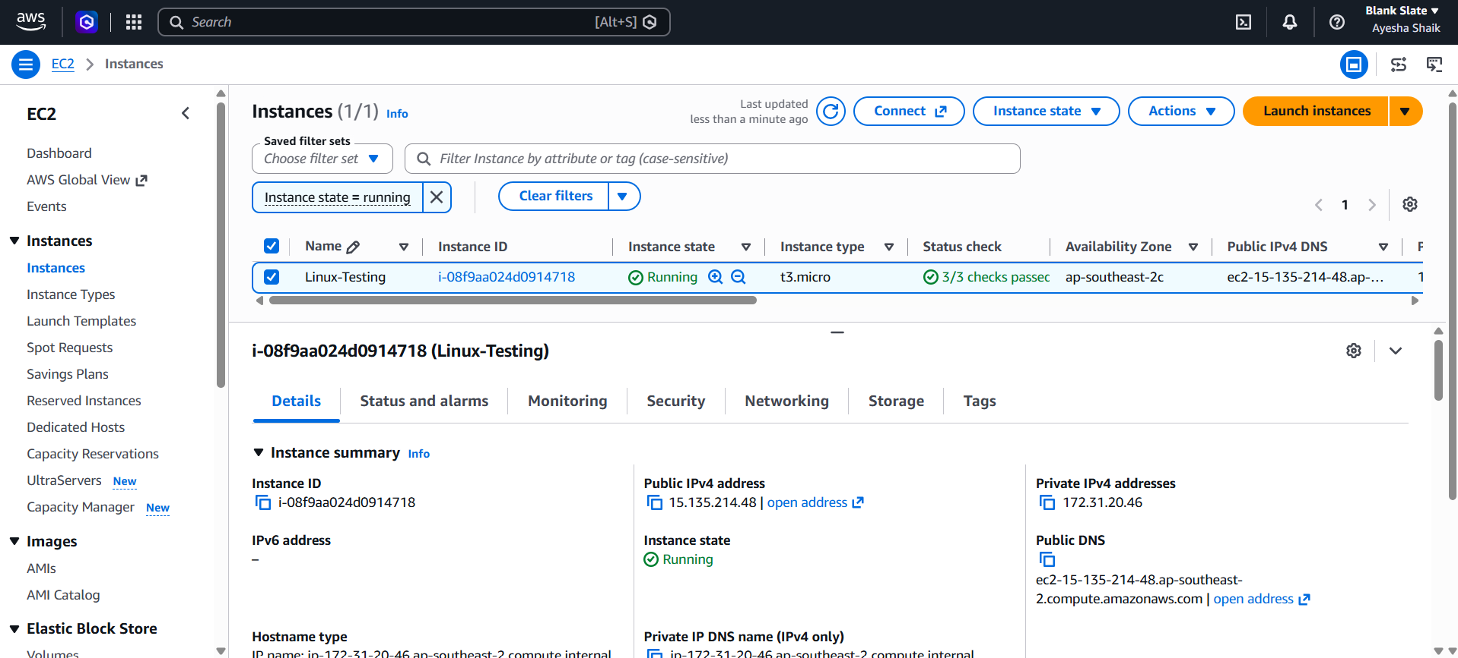
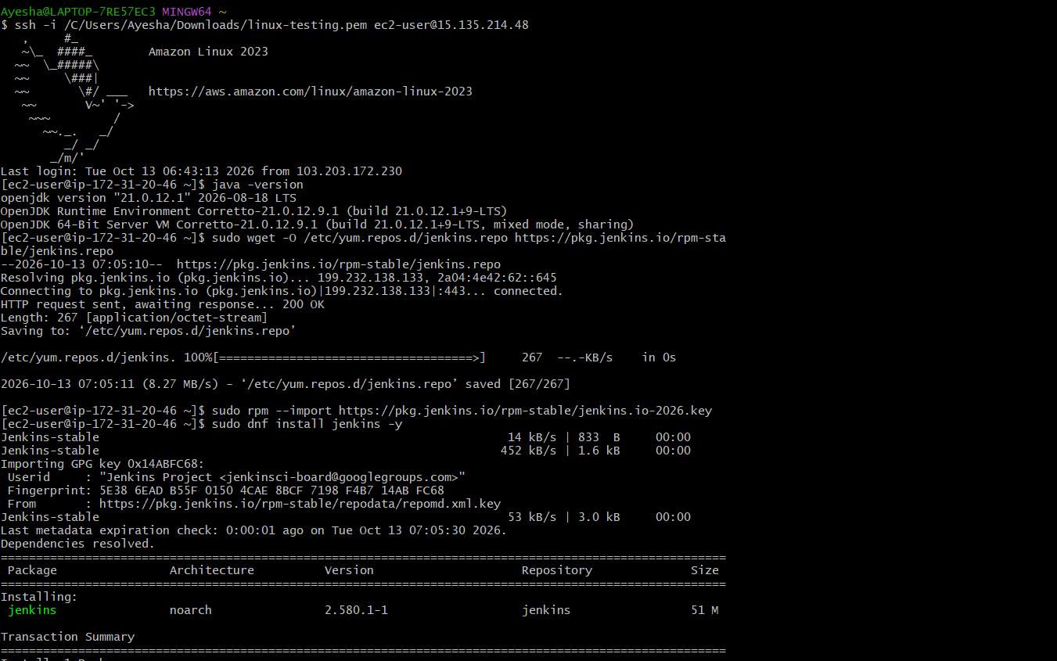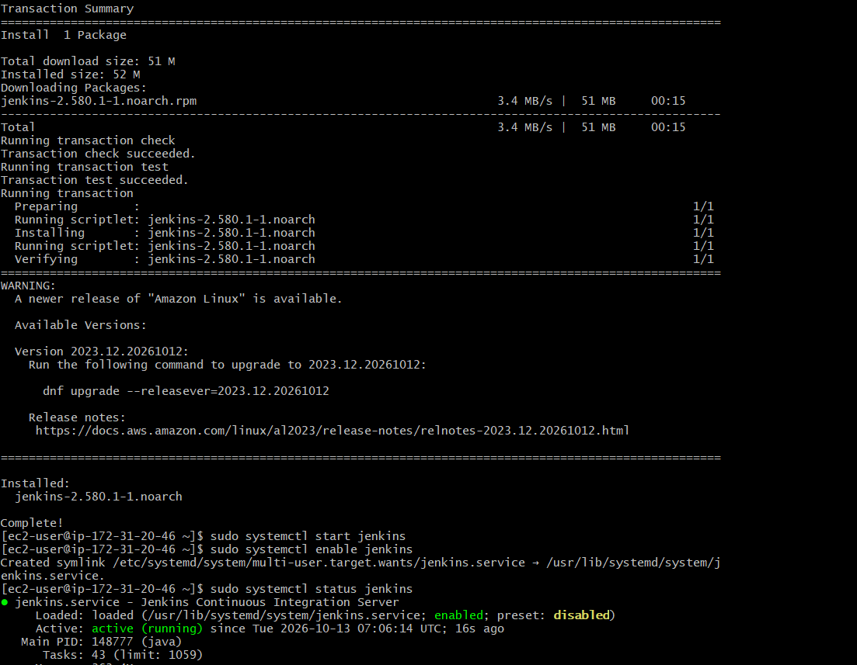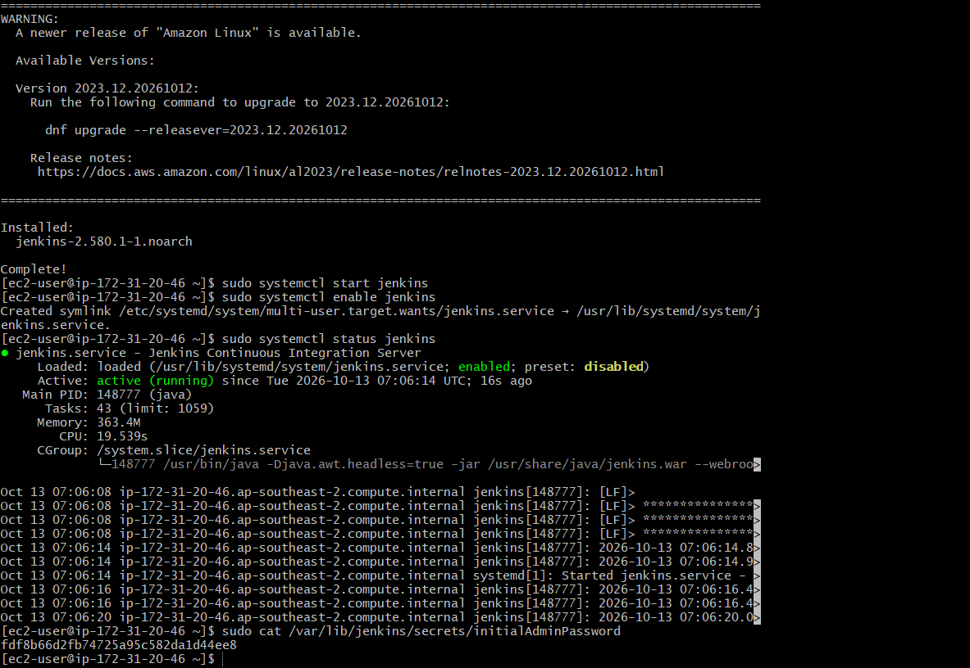

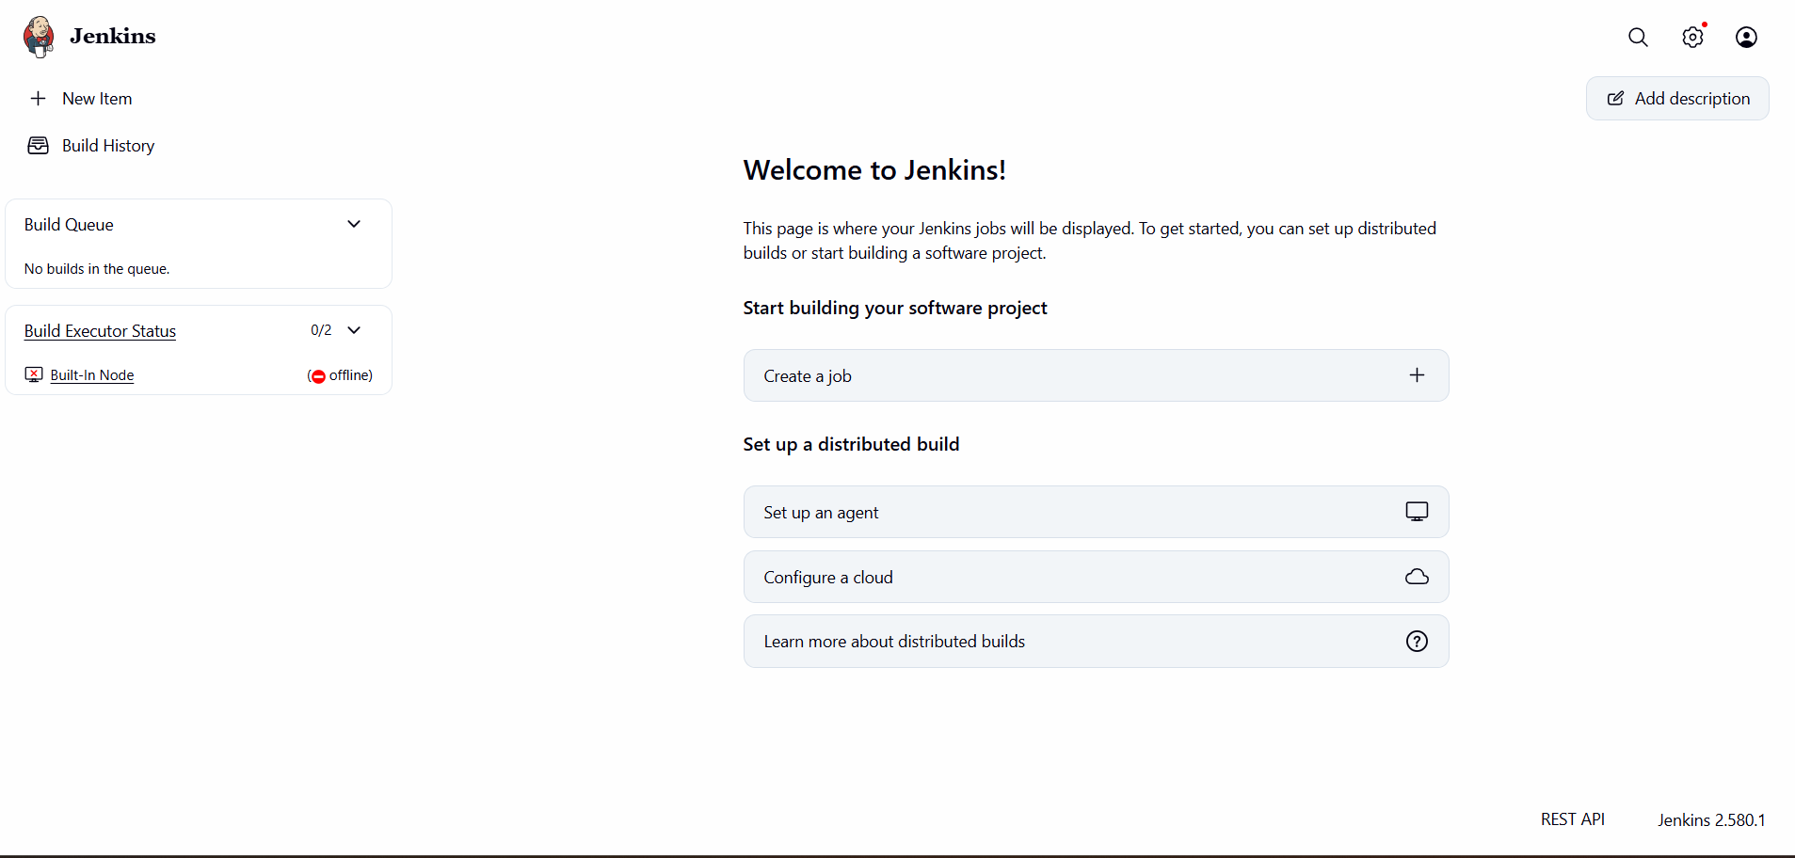

2.Setup Apache Tomcat on Ubuntu Virtual Machine

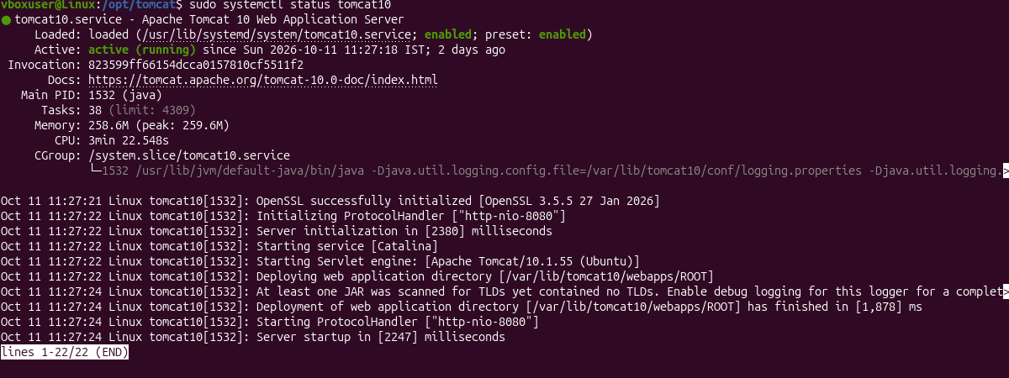

1. Update packages
sudo apt update
2. Install Tomcat 10
sudo apt install tomcat10 -y
3. Start Tomcat
sudo systemctl start tomcat10
4. Enable Tomcat at boot
sudo systemctl enable tomcat10
5. Check Tomcat status
sudo systemctl status tomcat10
Tomcat 10 is installed and running on Ubuntu VM.
3. Setup Docker Desktop on your local windows.
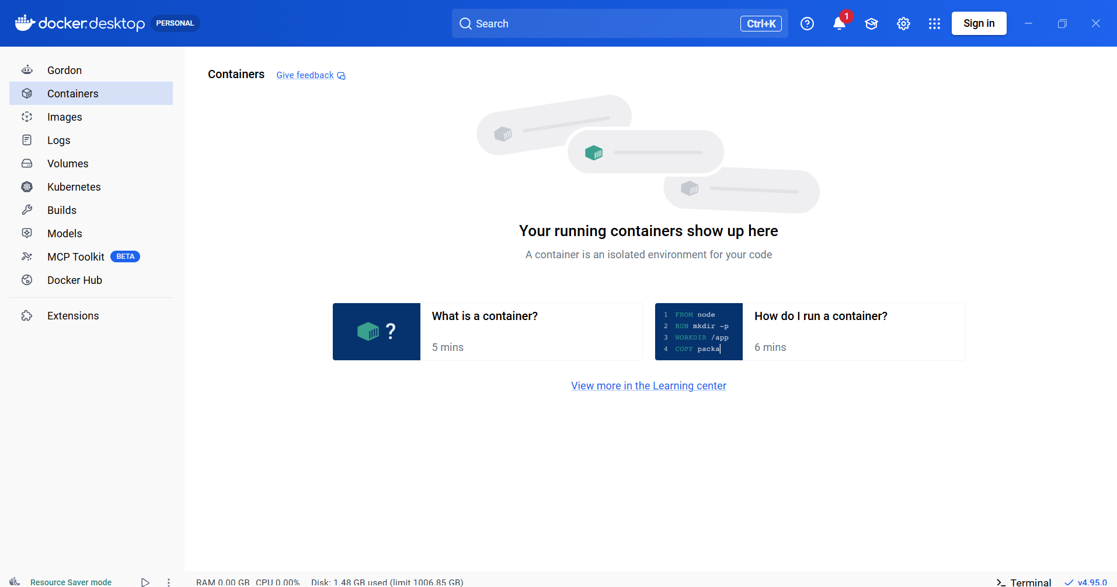
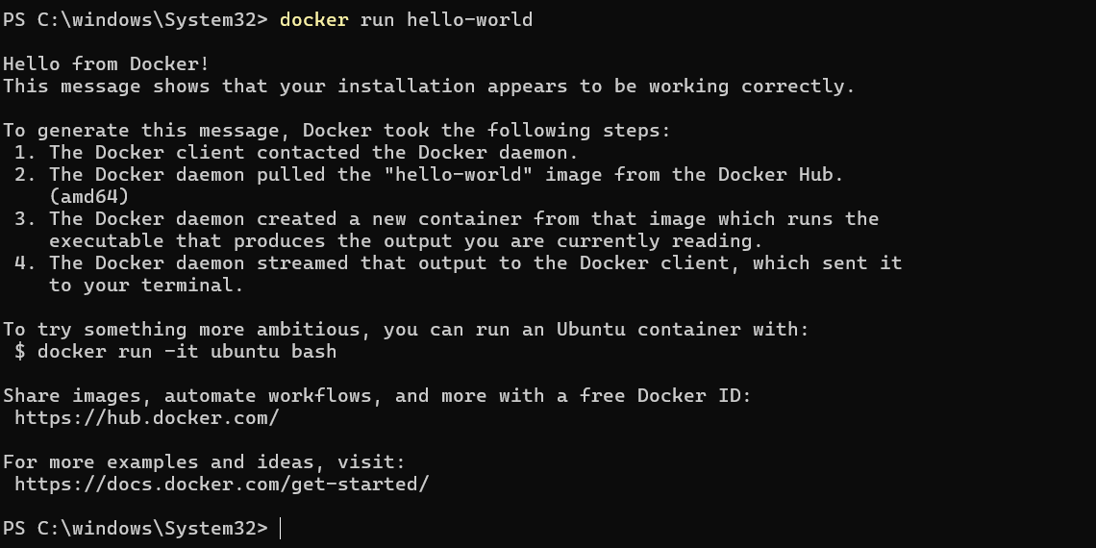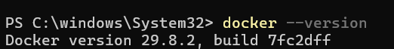
1. Check my system
I checked my Windows system type and confirmed that my computer uses a 64-bit processor.
2. Download Docker Desktop
I downloaded Docker Desktop for Windows (AMD64) from the official Docker website.
3. Install Docker Desktop
I opened the installer and selected Per-user installation (Recommended). I kept the desktop shortcut option enabled and completed the installation.
4. Open Docker Desktop
I opened Docker Desktop and waited for it to start successfully.
5. Verify Docker installation
I opened Git Bash and checked the Docker version using:
docker --version
6. Test Docker
I ran the following command to verify that Docker was working correctly:
docker run hello-world
I confirmed the installation when I received the "Hello from Docker!" message.

